**Panel Econometrics**

Assignment #3

By Chuxin Liu

**Question 1: One-factor RE model with AR(1) structure in the idiosyncratic disturbance**

1. After accounting for serial correlation, the scale of all estimates of the slope parameters decreases. Moreover, the scale of the estimates are decreasing with $ρ$, with “tscorr” generating the smallest $ρ$ and “freg” generating the largest $ρ$;

This is due to the fact that ${\hat{Ω}}^{-1}$, used in FGLS estimator, varies with the value of $ρ.$

|  |  |  |  |
| --- | --- | --- | --- |
| Table 1: Question 1 Regression Results | | | |
|  | (1) | (2) | (3) |
|  | RE | RE TSCORR | RE FREG |
| LINCOMEP | 0.555*** | 0.418*** | 0.379*** |
|  | (9.39) | (7.16) | (5.82) |
|  |  |  |  |
| LRPMG | -0.420*** | -0.344*** | -0.289*** |
|  | (-10.52) | (-10.16) | (-9.02) |
|  |  |  |  |
| LCARPCAP | -0.607*** | -0.547*** | -0.535*** |
|  | (-23.78) | (-20.90) | (-18.19) |
|  |  |  |  |
| Constant | 1.997*** | 1.735*** | 1.628*** |
|  | (10.83) | (8.32) | (6.18) |
|  |  |  |  |
| Observations | 342 | 342 | 342 |
| sigma_u | 0.196 | 0.194 | 0.240 |
| sigma_e | 0.0923 | 0.0638 | 0.0525 |
| rho_ar |  | 0.744 | 0.899 |
| rho_fov |  | 0.902 | 0.954 |

1. After accounting for serial correlation, $σ_{μ}$ slightly decreases by using “tscorr” but increases by using “freg”. On the other hand, $ρ_{fov}$, which is the “fraction of variance due to u_i (random effects)” are both higher than 90% in two AR(1) models.

**Question 2**

1. Bai’s estimator

Using the “regife -- fits a model with interactive fixed effects following Bai (2009)” package in STATA, we get:

|  |  |
| --- | --- |
| Table 2: Bai's Estimate | |
|  | (1) |
|  | Bai |
| LINCOMEP | 0.133 |
|  | (1.70) |
|  |  |
| LRPMG | -0.215*** |
|  | (-7.08) |
|  |  |
| LCARPCAP | -0.579*** |
|  | (-17.56) |
|  |  |
| Observations | 342 |

1. Estimate

|  |  |  |  |  |
| --- | --- | --- | --- | --- |
|  | __00000C | lincomep | lrpmg | lcarpcap |
| __00000C | 0.196262 |  |  |  |
| lincomep | 0.024018 | 0.006115 |  |  |
| lrpmg | 0.001928 | -0.00015 | 0.000921 |  |
| lcarpcap | 0.002999 | -0.00101 | 0.000214 | 0.00108893 |

1. Matrix F

|  |  |  |  |
| --- | --- | --- | --- |
|  | year | timefactor1 | timefactor2 |
|  |  |  |  |
| 1 | 1960 | 0.8039833 | 0.1248221 |
| 2 | 1961 | 0.7681092 | 0.0878248 |
| 3 | 1962 | 0.7736262 | 0.0957043 |
| 4 | 1963 | 0.763321 | 0.0929261 |
| 5 | 1964 | 0.7301896 | 0.0580254 |
|  |  |  |  |
| 6 | 1965 | 0.7212067 | 0.0410134 |
| 7 | 1966 | 0.6831577 | 0.0347316 |
| 8 | 1967 | 0.6557953 | 0.0225407 |
| 9 | 1968 | 0.6342181 | 0.0003155 |
| 10 | 1969 | 0.6341891 | -0.0220295 |
|  |  |  |  |
| 11 | 1970 | 0.6117181 | -0.0398424 |
| 12 | 1971 | 0.5908068 | -0.0610515 |
| 13 | 1972 | 0.5705366 | -0.0796437 |
| 14 | 1973 | 0.5402105 | -0.0879394 |
| 15 | 1974 | 0.5829835 | -0.0927294 |
|  |  |  |  |
| 16 | 1975 | 0.5469649 | -0.086542 |
| 17 | 1976 | 0.5489455 | -0.0919573 |
| 18 | 1977 | 0.5382423 | -0.0976816 |
| 19 | 1978 | 0.5295537 | -0.0975055 |

Time factors have the same trend across time.

1. Matrix

|  |  |  |  |
| --- | --- | --- | --- |
|  | country | idfactor1 | idfactor2 |
|  |  |  |  |
| 1 | AUSTRIA | -1.033065 | -1.278619 |
| 2 | BELGIUM | -1.039979 | -0.0582454 |
| 3 | CANADA | 0.5684701 | -1.655095 |
| 4 | DENMARK | -0.6059405 | 0.6910873 |
| 5 | FRANCE | -1.027912 | -0.5493649 |
|  |  |  |  |
| 6 | GERMANY | -1.057861 | -1.062855 |
| 7 | GREECE | -1.20551 | -1.334306 |
| 8 | IRELAND | -0.8033177 | -0.9179363 |
| 9 | ITALY | -1.329899 | 0.0135234 |
| 10 | JAPAN | -0.8579816 | 2.020286 |
|  |  |  |  |
| 11 | NETHERLA | -0.9455401 | 0.7927306 |
| 12 | NORWAY | -0.8797613 | -0.1851349 |
| 13 | SPAIN | -1.65748 | -0.037792 |
| 14 | SWEDEN | -0.8837644 | 0.0294197 |
| 15 | SWITZERL | -0.6547827 | -0.5352372 |
|  |  |  |  |
| 16 | TURKEY | -1.232097 | 1.019035 |
| 17 | U.K. | -0.879118 | -0.3535626 |
| 18 | U.S.A. | 0.6825891 | -1.701091 |

Idfactors seems to have opposite trend across countries.

**Question 3**

1. **Restrictions**

The null hypothesis in an additive-effects model:

The restrictions are on and ,

and

Thus the alternative hypothesis is:

Where and

The test is distributed in where p is the number of regressors.

1. **Hausman Test**

Hausman Test between within-group estimator and interactive-effects estimator:

Null hypothesis: , which implies:

Therefore, Hausman Test Statistics:

1. **Hausman Test statistics**

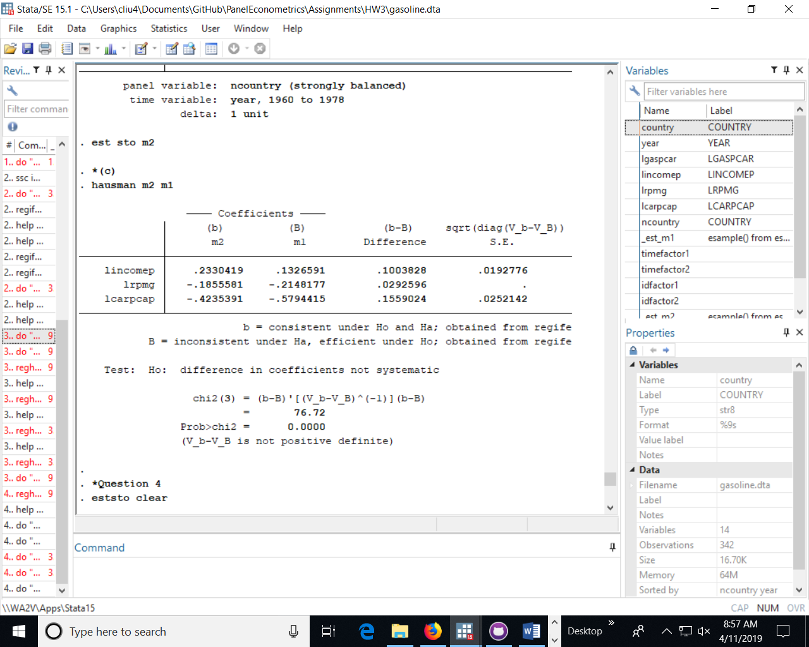

1. **Hausman Test inference**

P-value=0.0000: Reject the null hypothesis of the additive-effects model.

**Question 4: Pesaran’s MG estimator and its variance**

|  |  |
| --- | --- |
| Table 4: Question 4 MG Esimator | |
|  | (1) |
|  | MG |
|  |  |
| LINCOMEP | 0.350** |
|  | (2.83) |
|  |  |
| LRPMG | -0.277*** |
|  | (-5.94) |
|  |  |
| LCARPCAP | -0.432*** |
|  | (-7.64) |
|  |  |
| Constant | 2.193*** |
|  | (3.88) |
|  |  |
| Observations | 342 |

|  |  |  |  |  |
| --- | --- | --- | --- | --- |
|  | lincomep | lrpmg | lcarpcap | _cons |
| lincomep | 0.015325 |  |  |  |
| lrpmg | -4.8E-05 | 0.002175 |  |  |
| lcarpcap | -0.00522 | -0.00016 | 0.003196 |  |
| _cons | 0.053986 | 0.002266 | -0.00642 | 0.31966 |

**Codes for Question 1:**

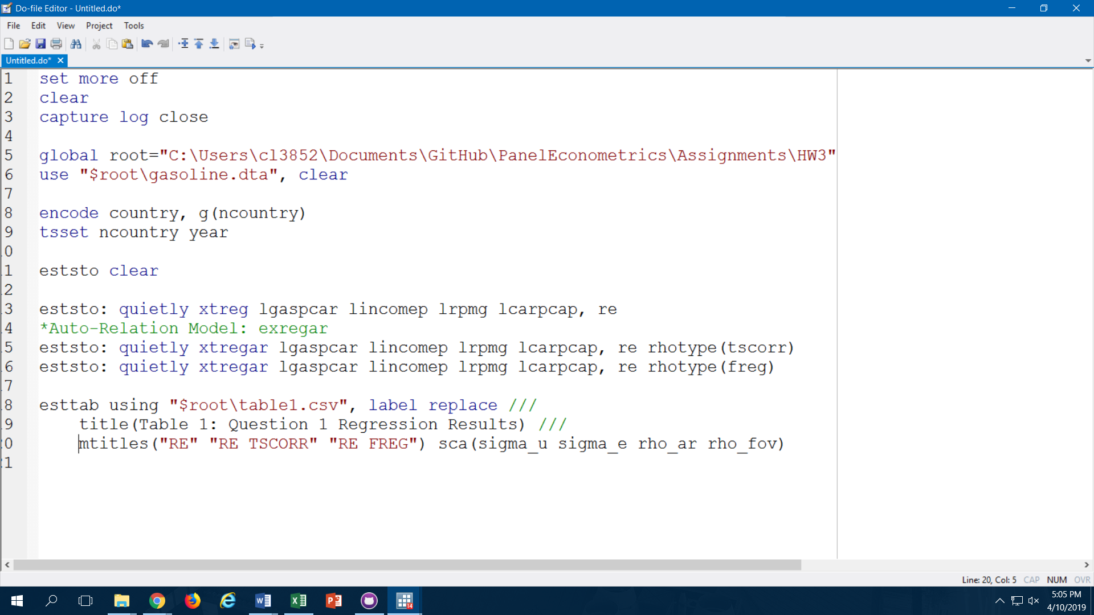

**Codes for Question 2:**

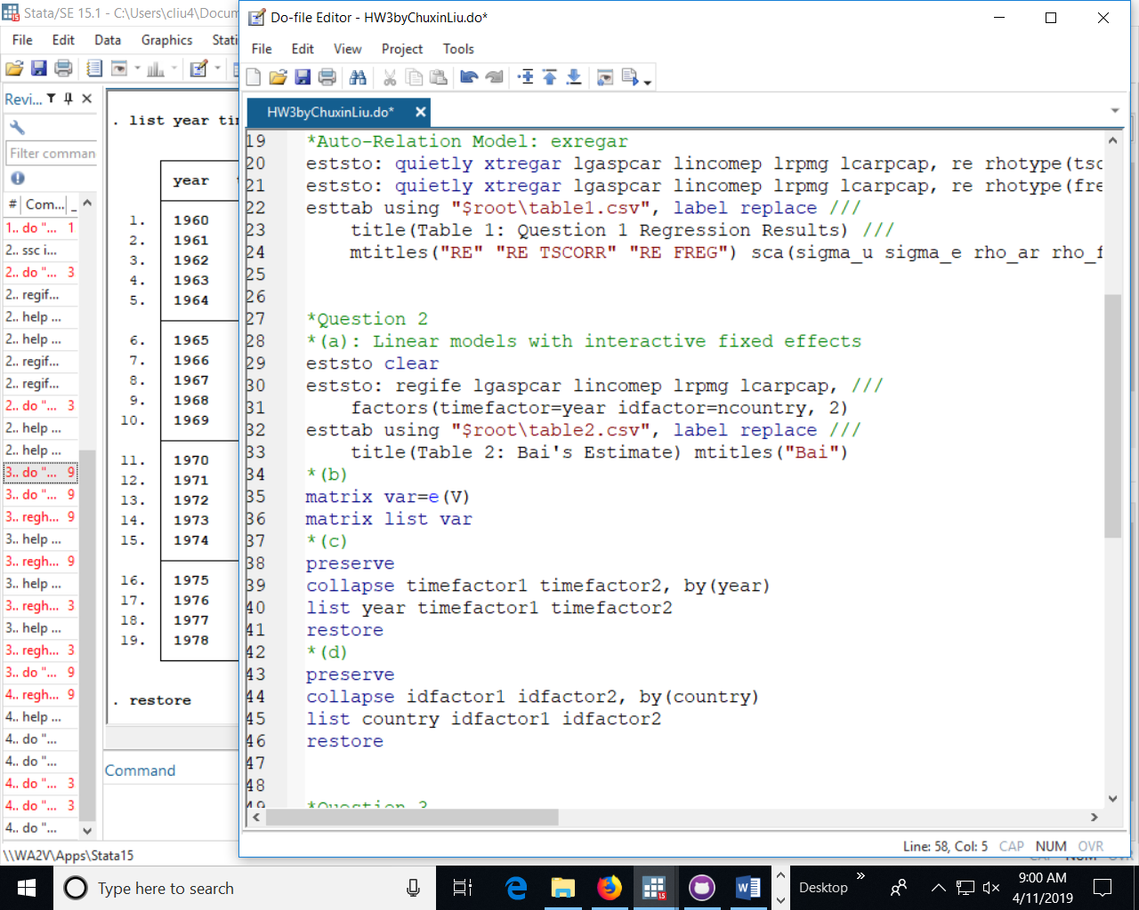

**Codes for Question 3:**

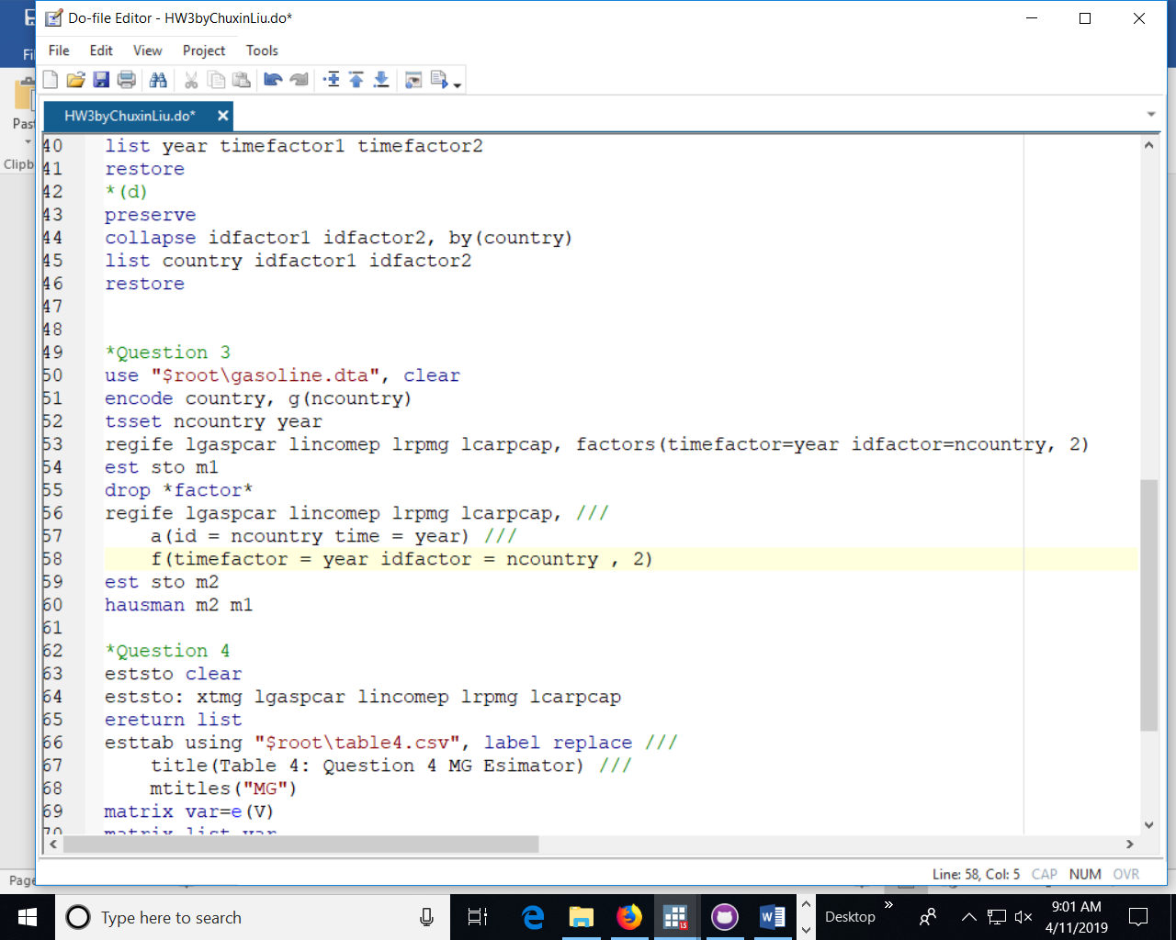

**Codes for Question 4:**

